Sign in to Jetbrains Account

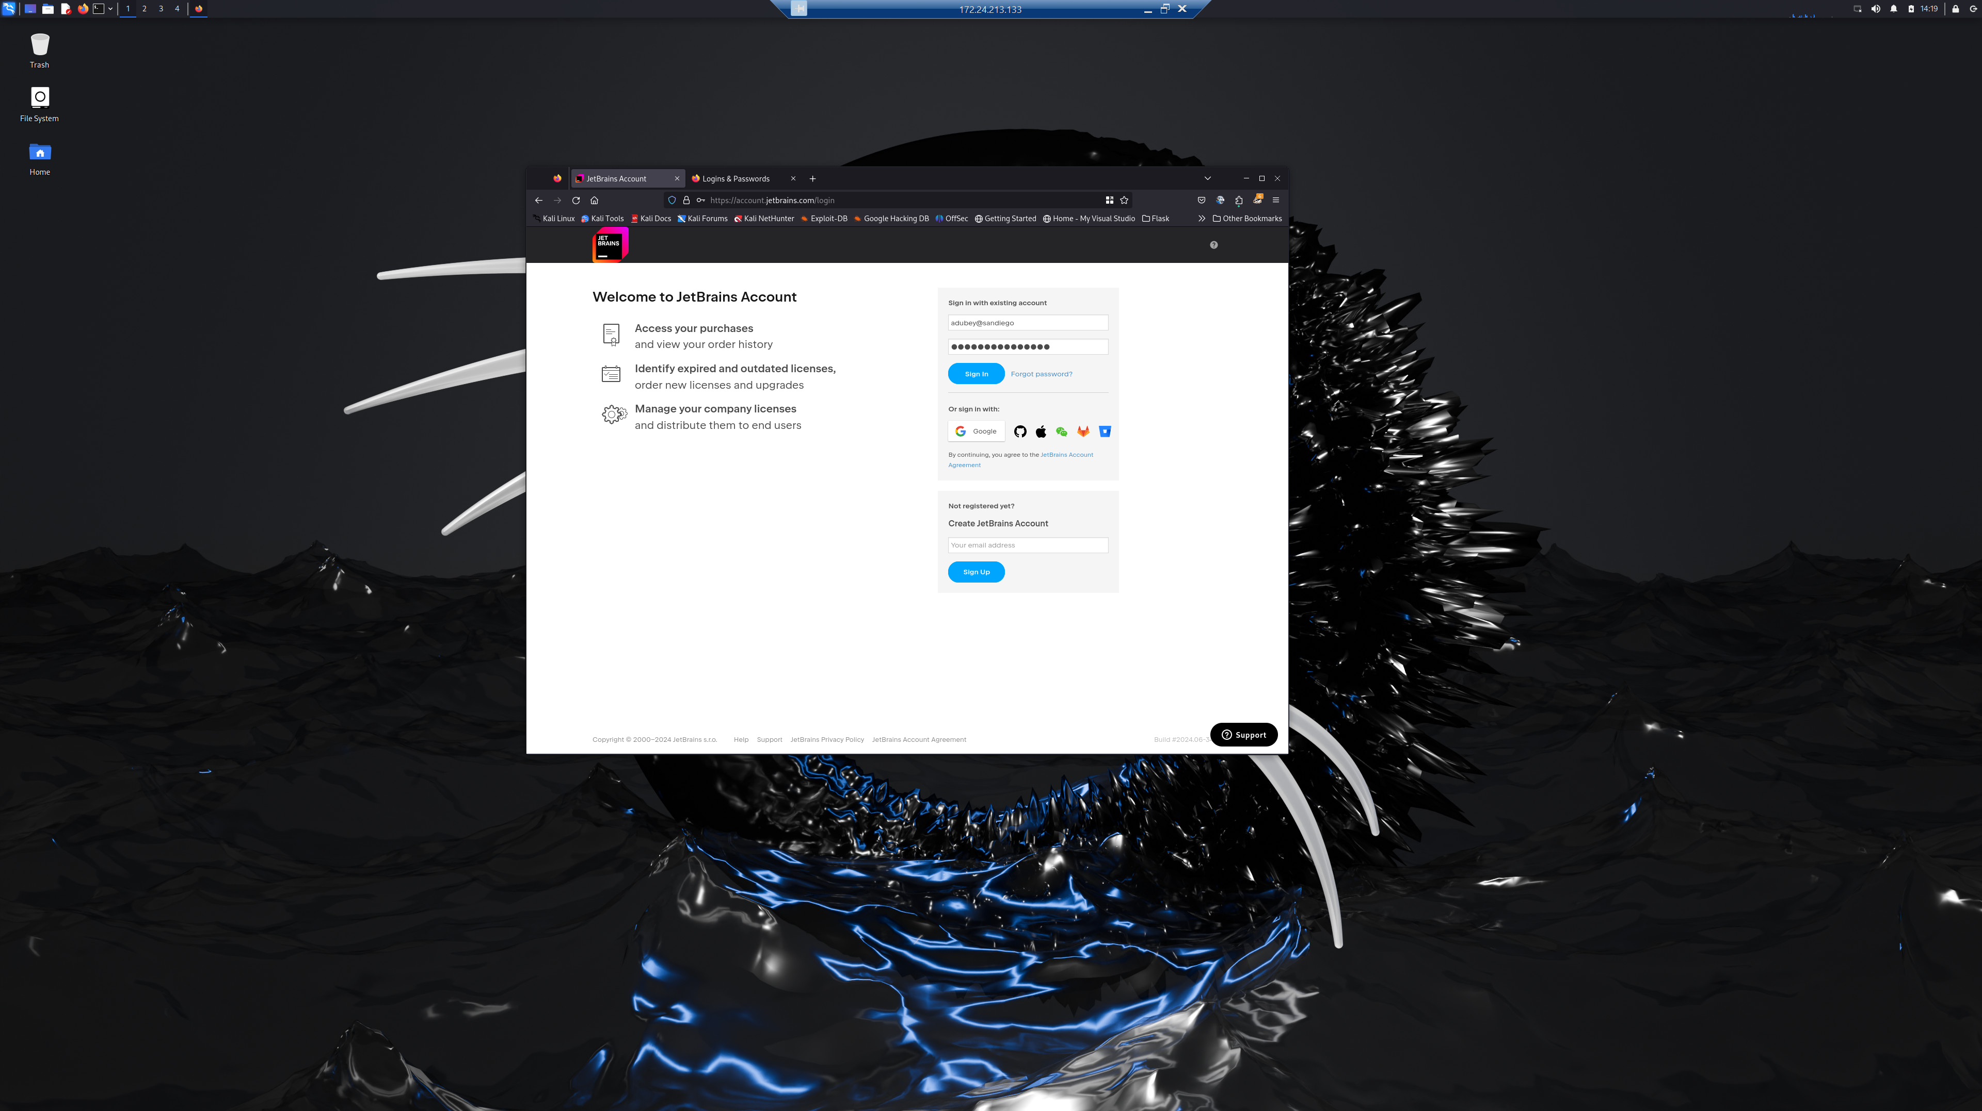

Symlink After Installation of PyCharm IDE using Jetbrains Toolbox

PyCharm Launch

Section 1.1 – 1.9

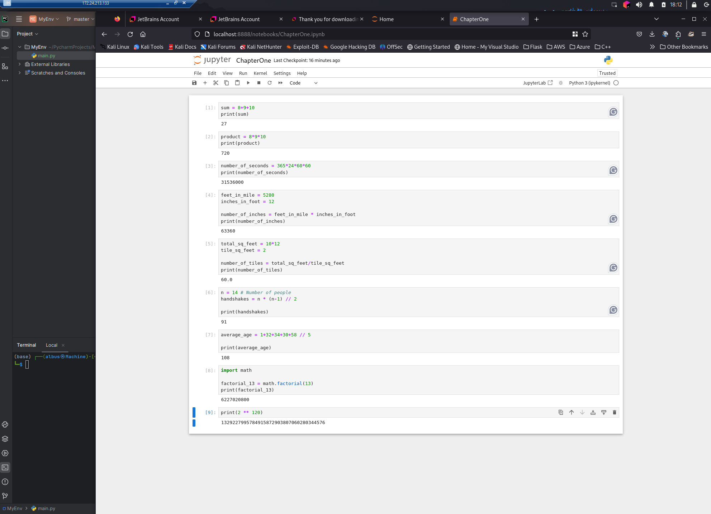

Section 1.10 – 1.12

Turtle: ds.py

